**Name: Libiya Jose**

**Roll No: 14**

**Batch:S2 MCA B**

**Date:06/06/2022**

**NETWORKING & SYSTEM ADMINISTRATION LAB**

**Experiment No.: 25**

**Aim**

**Networking commands**

**Procedure**

**ip config:**

Basic details of system connected to a network

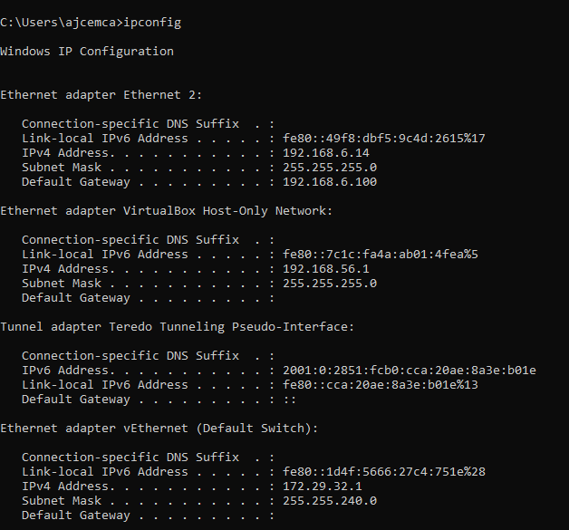

**ipconfig/all:**

Detailed study of system connected to network

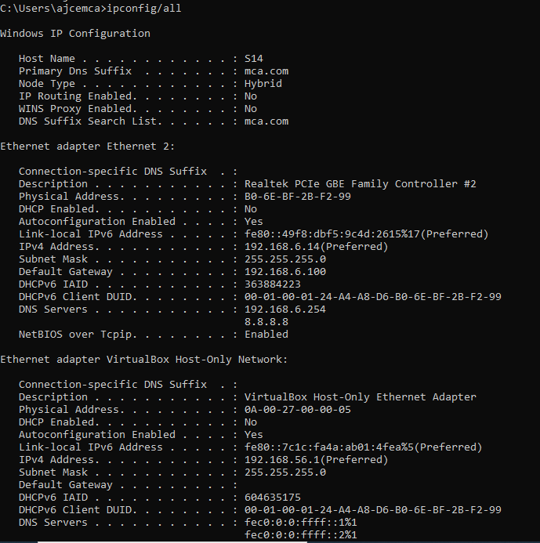

**nslookup:**

connect to which server

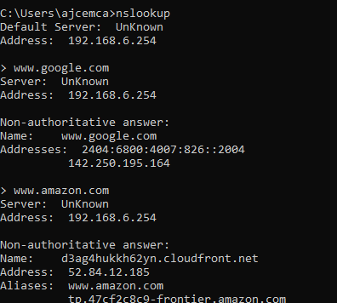

**Ping:**

identify the destination host

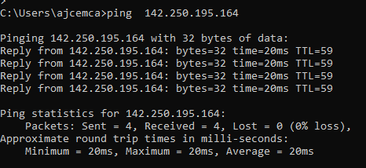

**Tracert:**

How many router ie needed to overcome to reach destination

traceart “ip address”

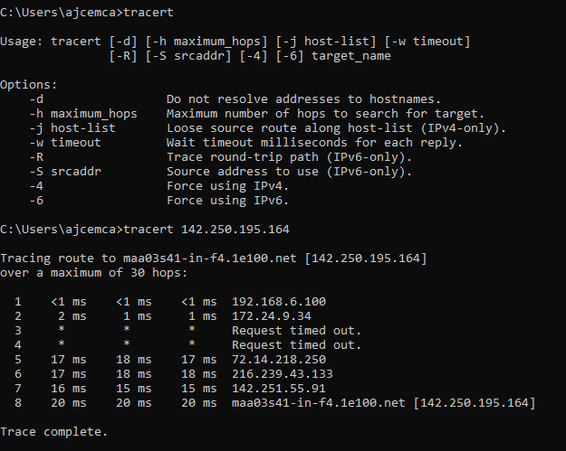

**Route print:**

to access our system routing table

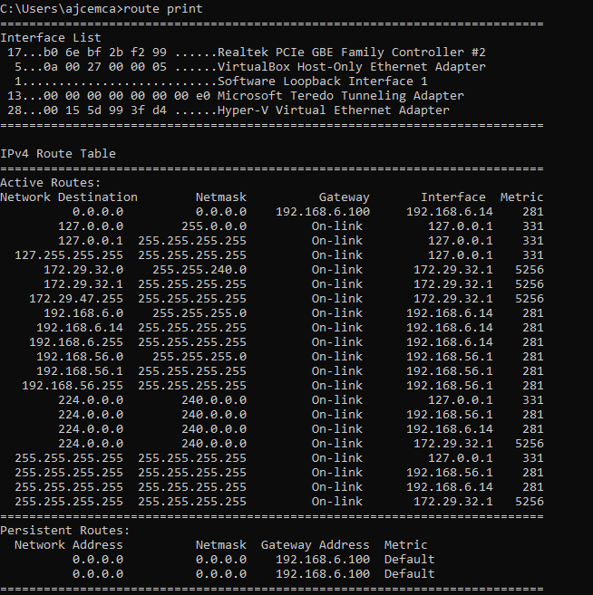

**netstat:**

the available number of connection through tcp and udp

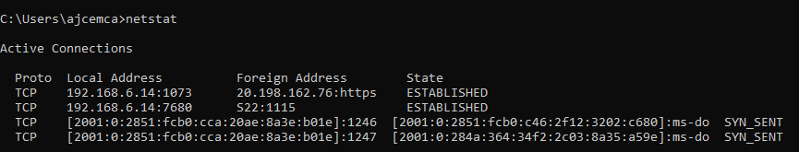

**arp:**

arp command manipulates the System’s ARP cache. It also allows a complete dump of the ARP cache. ARP stands for Address Resolution Protocol. The primary function of this protocol is to resolve the IP address of a system to its mac address, and hence it works between level 2(Data link layer) and level 3(Network layer).

